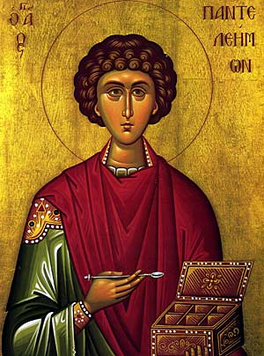
Clearly you were honored with the name Panteleimon by God, for like Him you were merciful. In accordance with your ways, you were given a fitting name. For you show mercy and sympathy to all, and you provide them with two-fold remedies. Feeding and curing them as you do, O glorious and blessed Saint, you direct them to divine and splendid knowledge of Christ.
(from the Lauds of Otrhros of the feast of St. Panteleimon, plagal 4th)

I would like to draw our attention to one of the wonderful saints commemorated in the month of July, St. Panteleimon (July 27th). As the hymn above so beautifully illustrates, he was a healing saint that had mercy and compassion for others healing them and directing them toward God.
This hymn and the ministry of St. Panteleimon offer beautiful insight into how we can intentionally minister to our flocks. The local parish is a place where the faithful should come to understand that they can find healing. It is a place where they can be understood, loved, cared for and directed toward Christ.
It is important to create an atmosphere in the parish that allows people to comfortably come to worship and offer up their pains and sorrows to God in prayer, so that they can find healing. The sacraments of Holy Unction and Holy Confession should be stressed often, so that people are aware that these sacraments are offered to bring them closer to Christ and make them whole. The Sunday sermon should convey to the people that our faith must be applied to our lives and that the Church has the answers for which they are searching.
Finding ways to communicate and connect with our people when they are in need is important. How often do we find out much after the fact that someone was in the hospital or going through a crisis. In fact, people get upset that no one from church visited even though they did not inform anyone of their illness. Many times people are afraid to call the priest because they do not want the sick person to think that they are dying.
Sometimes people feel for whatever reason that the priest is too busy and they do not want to bother him with their troubles. Having an understanding about the signals the parish gives or the impressions parishioners may develop is important in the process of connecting to people and ministering to them.
The prayers and sacraments of the Church are so powerful and certainly direct us to Christ. Reflecting on the ministry of St. Panteleimon reminds us to continue to be vigilant in looking after the physical and spiritual needs of our fellow parishioners whether we are clergy or laity. The clergy and laity working together must develop new ways to reach out to the faithful in our ever changing environment which has its constant needs and demands.
Many parishes have excellent visitation ministries and it would be great to share ideas of how we organize these ministries, so that we can learn from one another.
May the prayers of St. Panteleimon be with us as we discern ways to care for those that the Lord has entrusted to us supporting them in their struggles and in their walk with Christ.

